**National University of Computer & Emerging Sciences**

**Karachi Campus**



**TITLE OF PROJECT**

**Project Report**

**Parallel And Distributed Computing**

**Section: BCS-5B**

**Group Members:**

**22K-4201 Sumaiya Waheed**

**22K-4364 Muhammad Sudais**

**22K-4493 Azka Sahar Shaikh**

**Project Title: Parallel Implementation of Fast Fourier Transform (FFT) for Image Processing**

This project focuses on parallelizing the Fast Fourier Transform (FFT) algorithm, a key operation in signal processing, to enhance computational efficiency. By using both MPI (Message Passing Interface) and OpenMP (Open Multi-Processing), the project explores their individual effectiveness in optimizing FFT computations for large datasets across distributed and shared-memory systems.

**Serial Execution Time:**

The initial FFT algorithm implementation performed the image processing operations sequentially. The total time for frequency domain image processing was measured using high-resolution clocks

**Outputs:**

### **32X32**

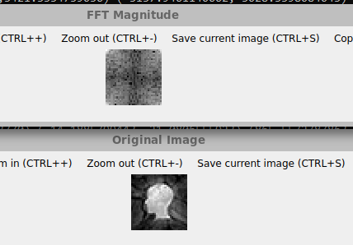

### **64x64**

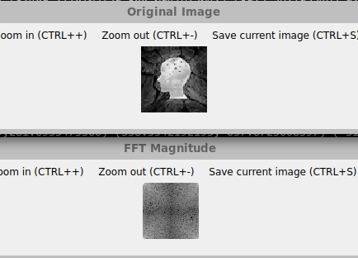

### **128x128**

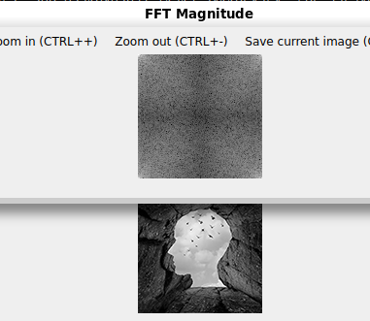

### **256x256**

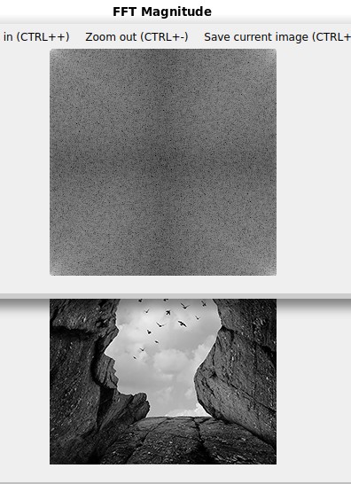

### **512x512**

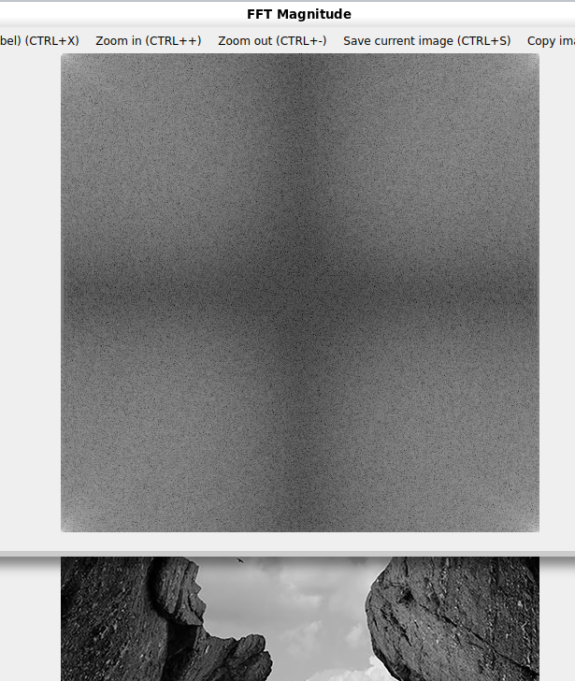

### **1024x1024**

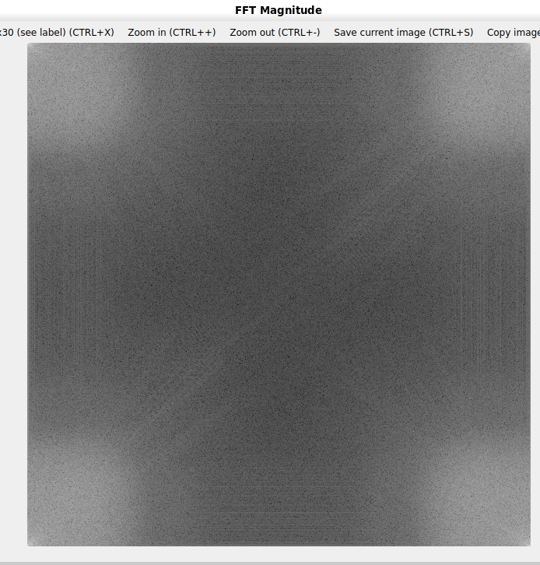

### **2048X2048**

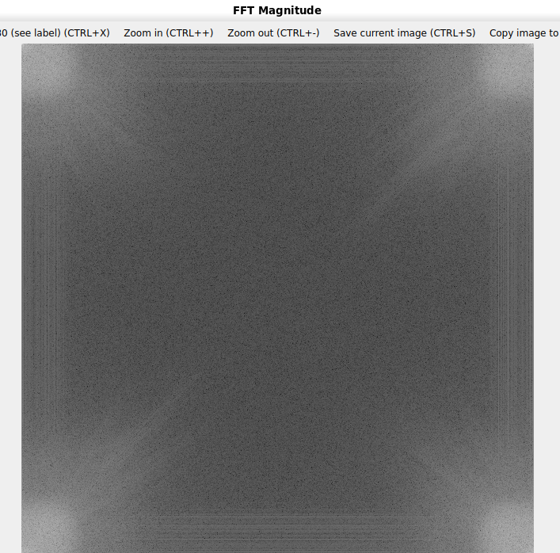

### 

### 

### 

### **4096X4096**

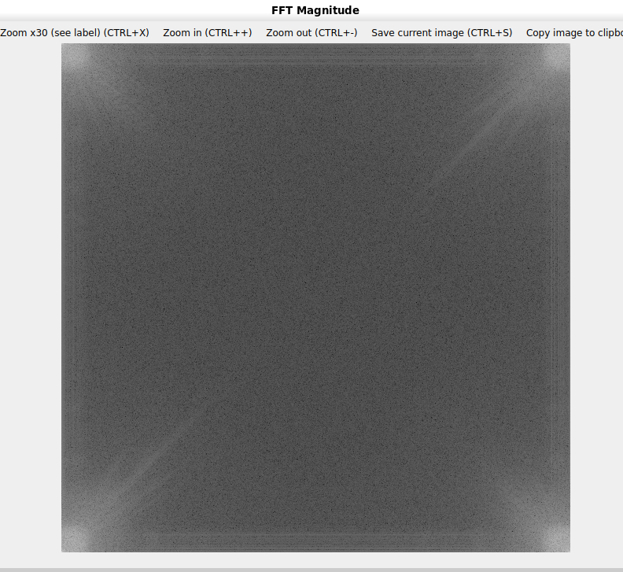



**Parallel Execution Time (OpenMP) :**

This is the performance of Fast Fourier Transform (FFT) on a grayscale image using OpenMP for parallelization. OpenMP pragmas are used extensively to improve the efficiency of various computational tasks. The #pragma omp parallel directive defines parallel regions where multiple threads execute concurrently, encompassing operations like image data conversion, FFT application, and transposition. The #pragma omp for directive is used to distribute loop iterations among threads, enabling parallel execution for tasks like row-wise and column-wise FFT, as well as magnitude calculation. To optimize nested loops, the #pragma omp parallel for collapse(2) directive is applied, particularly during image data conversion and magnitude computation, to parallelize both dimensions simultaneously. Additionally, #pragma omp parallel sections is used to divide independent recursive FFT calls into separate sections that are executed in parallel. The #pragma omp single directive ensures that specific tasks, such as data transposition, are executed by only one thread, as these operations are inherently sequential. This combination of directives ensures efficient parallelism, reducing execution time and making optimal use of available threads.

**Outputs:**

### **32X32**

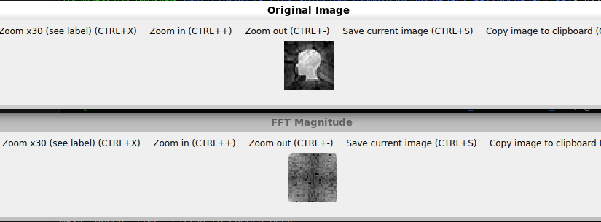

Time with 2 threads : 0.0064

Time with 4 threads : 0.0034

### **64x64**

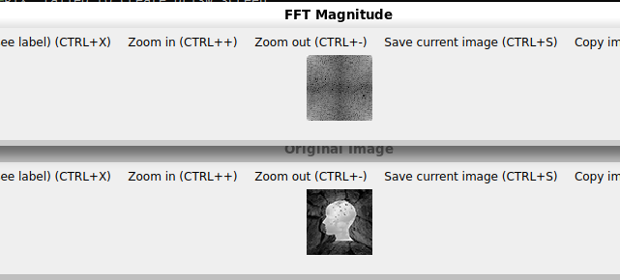

Time with 2 threads :0.0296

Time with 4 threads : 0.0031

### **128x128**

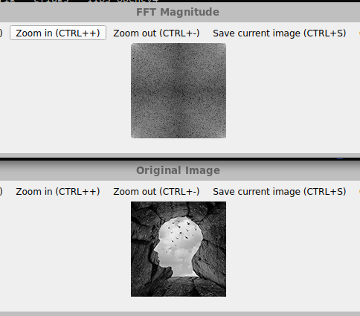

Time with 2 threads :0.1096

Time with 4 threads : 0.0144

### **256x256**

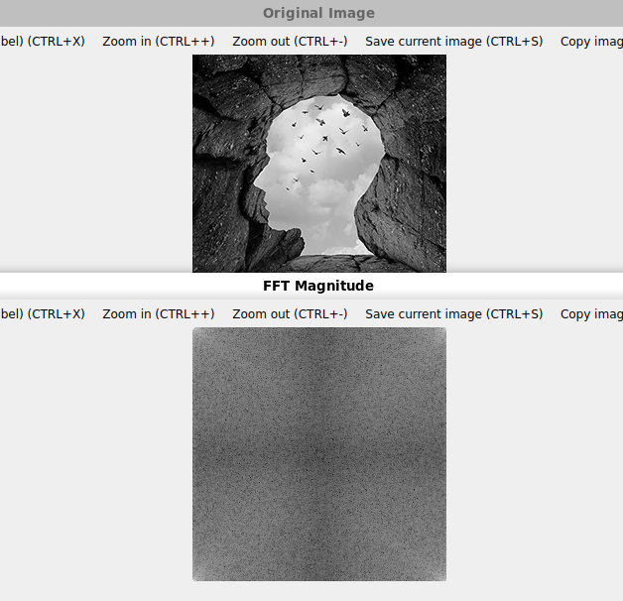

Time with 2 threads : 0.3839

Time with 4 threads : 0.0433

### **512x512**

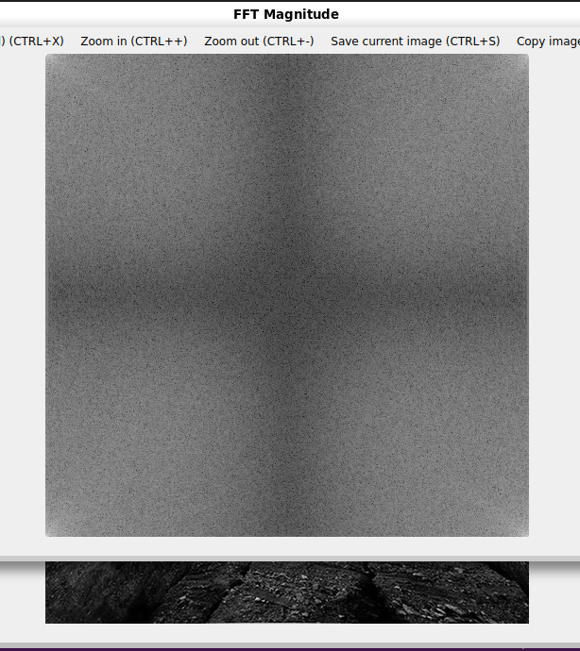

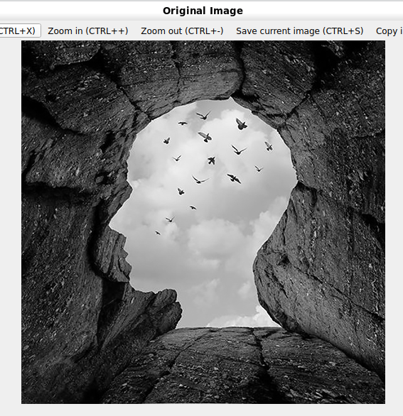

Time with 2 threads :1.6550

Time with 4 threads : 0.1867

### **1024x1024**

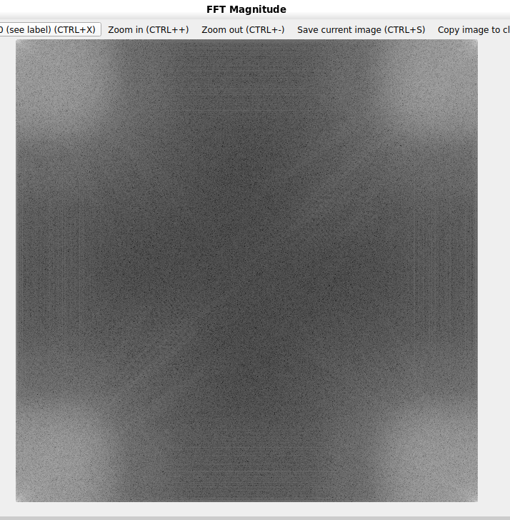

Time with 2 threads : 6.0427

Time with 4 threads : 0.6283

### **2048X2048**

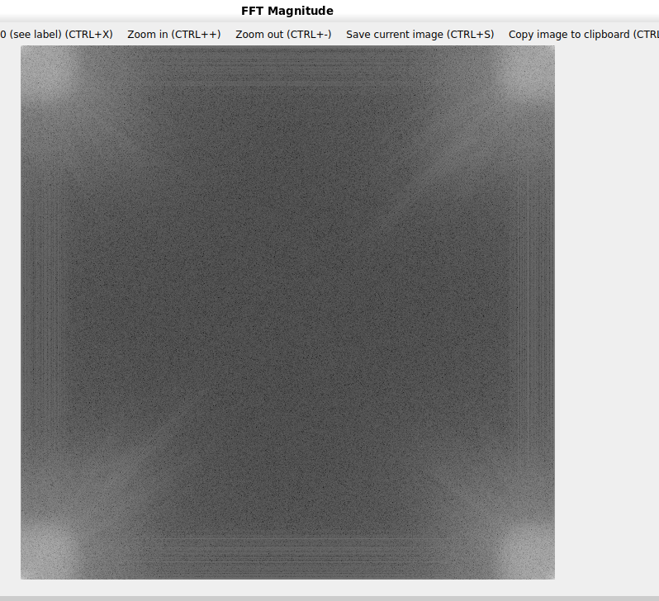

Time with 2 threads :24.2277

Time with 4 threads : 2.2690

### **4096X4096**

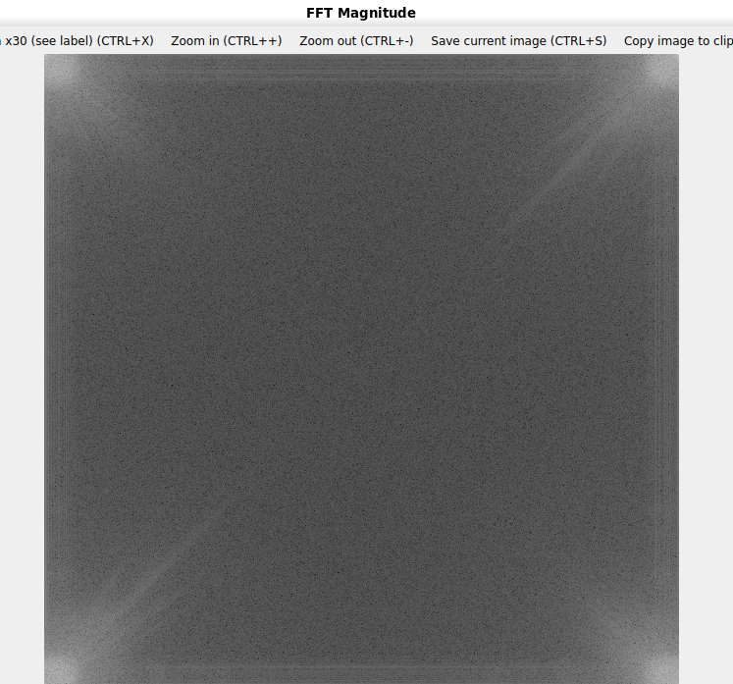

Time with 2 threads : 102.8970

Time with 4 threads : 9.2809

**Parallel Execution Time (MPI) :**

The MPI code performs parallel matrix-vector multiplication by distributing rows of a matrix across multiple processes for independent computation. The root process initializes the matrix and vector, then broadcasts the vector to all processes using MPI_Bcast. The matrix rows are divided among processes using MPI_Scatterv, ensuring each process receives only its assigned rows. Each process computes the dot product of its rows with the vector, forming a partial result vector. These partial results are gathered back at the root process using MPI_Gatherv to construct the final output vector. The program uses MPI_Wtime to measure the total parallel execution time, enabling performance evaluation. This parallel approach is designed to handle large matrix computations efficiently, leveraging multiple processes to reduce computational time while minimizing communication overhead.

**Outputs:**

### **32X32**



Time with 2 threads : 0.0113

Time with 4 threads : 0.0012

### **64x64**



Time with 2 threads : 0.0115

Time with 4 threads : 0.0062

### **128x128**



Time with 2 threads : 0.0276

Time with 4 threads : 0.0249

### **256x256**



Time with 2 threads : 0.1147

Time with 4 threads : 0.0910

### **512x512**



Time with 2 threads : 0.4848

Time with 4 threads : 0.3631

### **1024x1024**



Time with 2 threads : 1.7136

Time with 4 threads : 1.6654

### **2048X2048**



Time with 2 threads : 7.3185

Time with 4 threads : 6.6017

### **4096X4096**



Time with 2 threads : 34.4460

Time with 4 threads : 28.7083

**Graphical Representation of Serial and Parallel execution times**

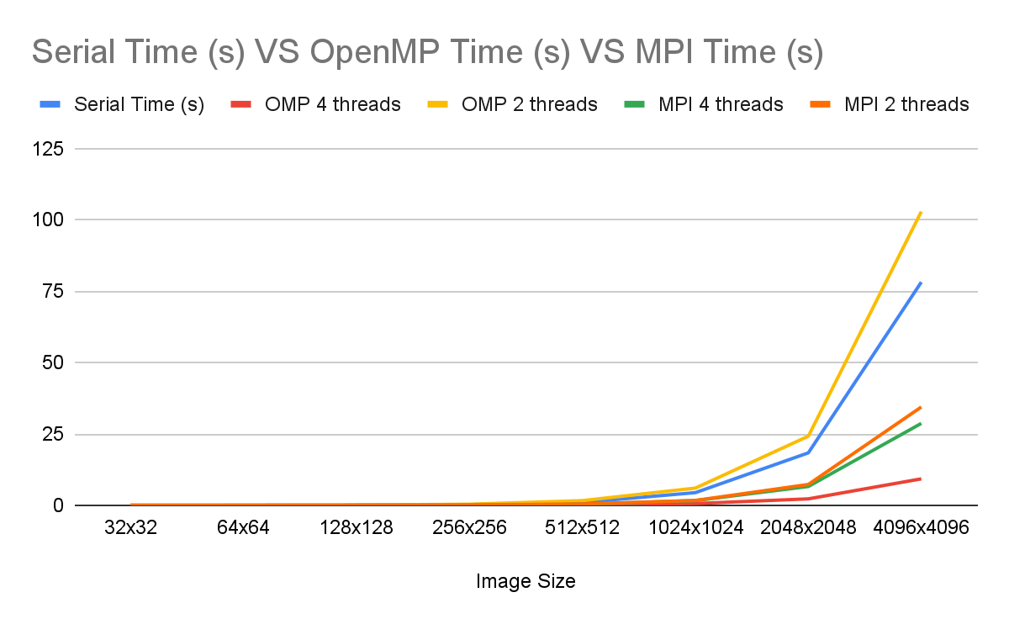

**Comparison of Speedup and efficiency:**

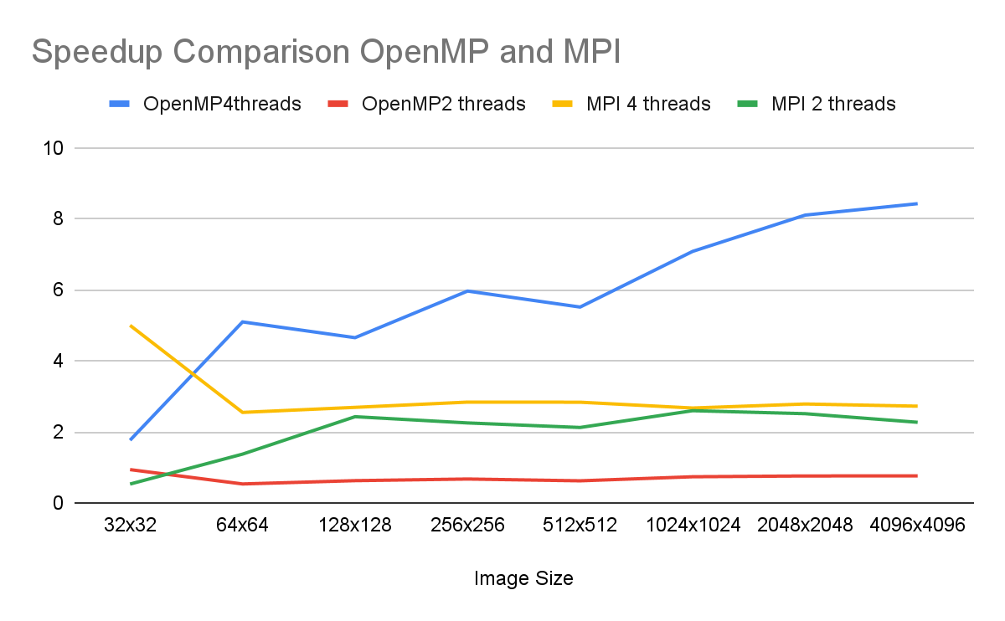

General Trend:

* + OpenMP (4 threads): The speedup increases consistently with image size, peaking at 8.4258 for the largest image (4096x4096). This demonstrates that parallelization benefits become more significant as the data size grows.
  + OpenMP (2 threads): Speedup is lower compared to 4 threads, as expected, but follows a similar increasing trend with image size. The maximum speedup achieved is 0.7599 for the largest image.
  + MPI (4 threads): Speedup increases with image size, indicating that MPI handles larger workloads efficiently. The highest speedup observed is 2.7853 for 2048x2048 images.
  + MPI (2 threads): Speedup is consistently lower than for 4 threads, showing that fewer threads limit parallel efficiency.

Small Images:

* + For smaller images (e.g., 32x32), speedup is limited across all implementations due to low computational demand, making parallel overhead more significant relative to processing time.

Comparison Between Techniques:

* + OpenMP shows better speedup for smaller images due to lower communication overhead compared to MPI.
  + For larger images, MPI achieves comparable or slightly better speedup due to its ability to distribute workloads effectively over a distributed environment.

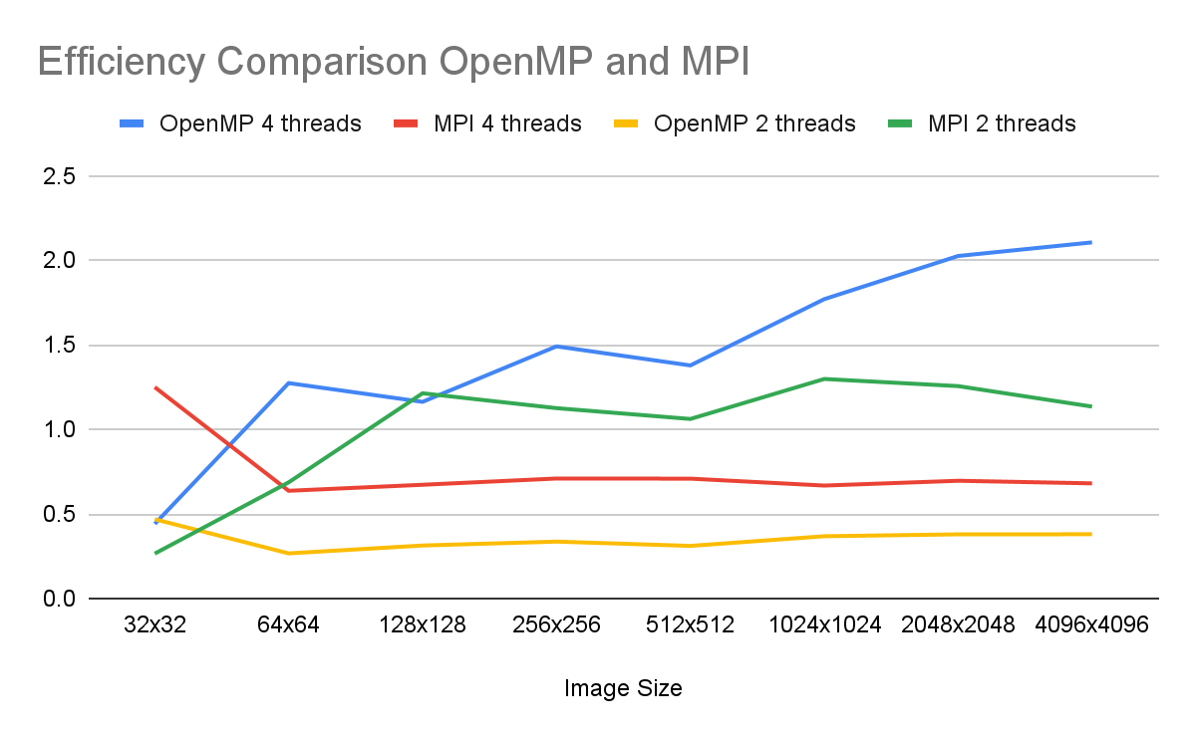

General Trend:

* + OpenMP (4 threads): Efficiency declines slightly as image size increases. For the largest image (4096x4096), efficiency drops to 2.1064, reflecting the overhead associated with managing multiple threads.
  + MPI (4 threads): Efficiency shows a slight decline as image size increases but remains relatively stable compared to OpenMP.

Smaller Images:

* + For smaller images (e.g., 32x32), efficiency is higher for OpenMP but lower for MPI due to MPI's higher communication overhead.

Comparison Between Techniques:

* + OpenMP achieves higher efficiency for smaller images due to its shared-memory model, which avoids the communication costs of MPI.
  + For larger images, MPI efficiency improves because communication overhead becomes less significant relative to the workload.

Threads Impact:

* + Efficiency per thread decreases when moving from 2 to 4 threads in both OpenMP and MPI, highlighting the overhead of managing more threads. However, the performance gain compensates for this loss in efficiency, particularly for larger images.

**Conclusion:**

In conclusion, this project effectively explores the parallelization of the Fast Fourier Transform (FFT) using both MPI and OpenMP independently. By employing MPI, we distributed the computational load across multiple nodes in a distributed-memory system, which proved beneficial for large-scale data. On the other hand, OpenMP provided parallelization within a shared-memory system, allowing efficient use of multiple cores on a single node. After comparing both approaches, we found that MPI excels in handling large datasets across multiple machines, while OpenMP performs better for shared-memory environments with fewer resources. Ultimately, the choice between MPI and OpenMP depends on the specific system architecture and problem size, and both techniques contribute significantly to optimizing the performance of FFT computations.